Date | Description | Evidence
1st December 1809  Age:35 | Awarded Absolute Pardon | 
Date unknown | Lists Thomas Beddows and Jonathan as obtaining their Conditional and Absolute Pardon. Jonathan’s being # 190
Feb 13th 1810  Age: 36 | Petition for mitigation of his sentence: Colonial Secretary Papers | 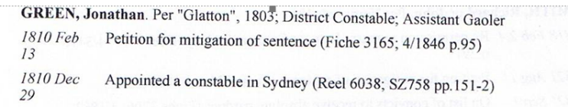
13th July 1810 | Surrender of Certificate of Freedom /Pardons  Note: Jonathan is listed as Free here supporting evidence he was given a pardon on Dec 1st 1809. | 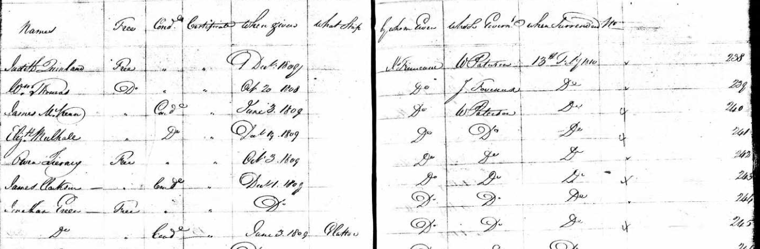
Date unknown | Looks like the cancellation of the Absolute Pardon | 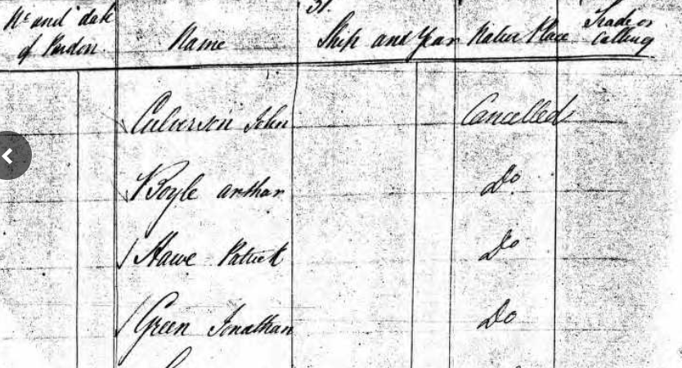
29th Dec 1810 | Appointed a Constable in Sydney-The Sydney Gazette published Gov Macquarie’s decision to divide Sydney into 5 districts and appointed constables to them. Each District would have a Watch House and streets would be clearly named and marked and regular house numbers introduced. | 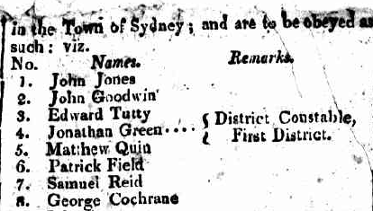
 |  | 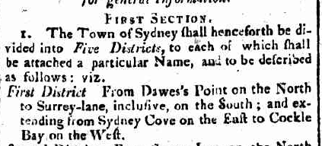
 |  | 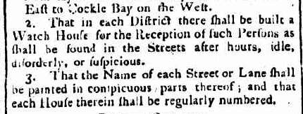
 | Duties of the Night Constables | 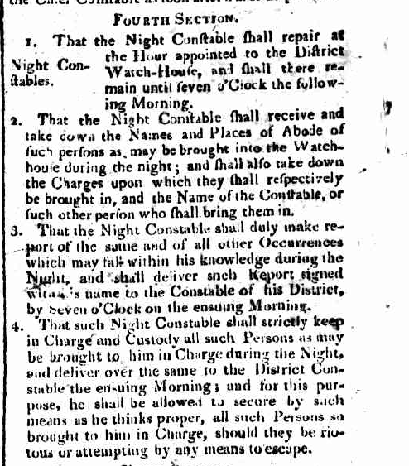
 | Duties of the Ordinary Constables- they were a mix of Police and Gaoler | 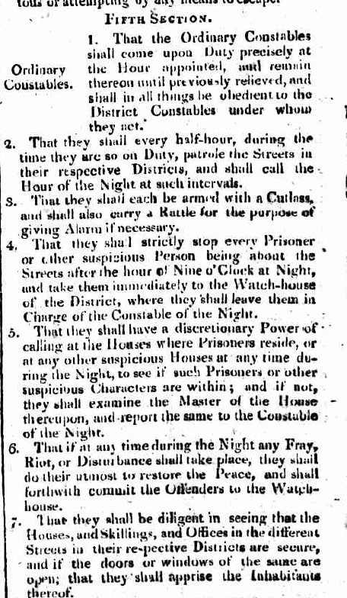
31/1/1813  Age: 39 | Conditional Pardon  Index to Letters P.M.S 4/1846  Index to Letters NSW Archives  P.M.S 4/1849  The letters tell us that King may well have granted Jonathan a pardon for his catch of criminals ie kin 1809 but it was time limited and needed renewing. Jonathan is asking for it to be renewed.  Letters came from: https://www.ourfamilypast.com/article/home/12785/about-story | 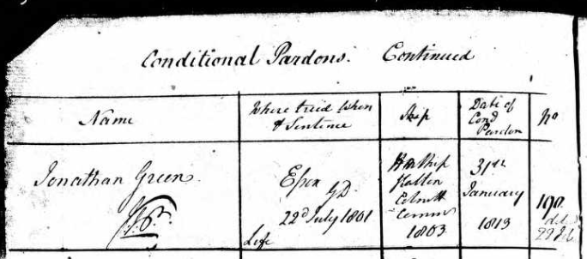  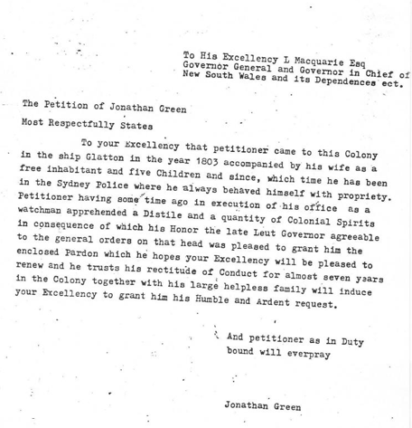  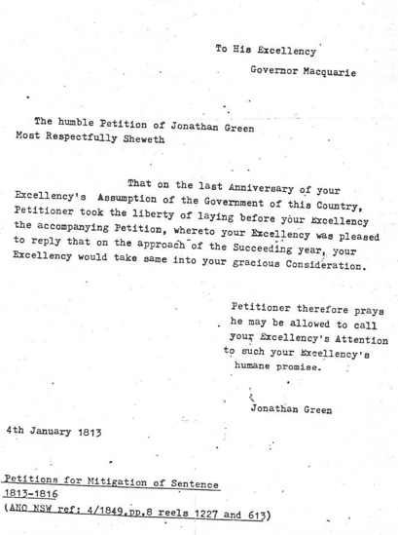
26th Oct 1811-24th August 1819 | Colonial Secretary’s Papers indicates Jonathan was paid from the Police Fund. He was appointed in Dec 1810 perhaps to commence in 1811. | 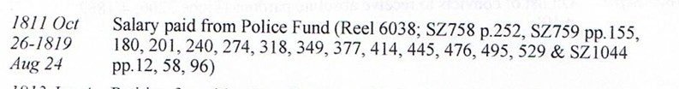  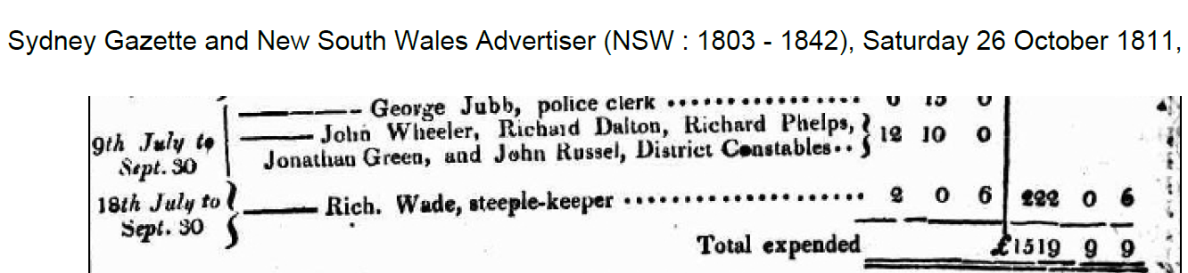
30th April 1814  Age: 40 | Sydney Gazette and New South Wales Advertiser (NSW : 1803 - 1842), Saturday 30 April 1814, page 2  National Library | 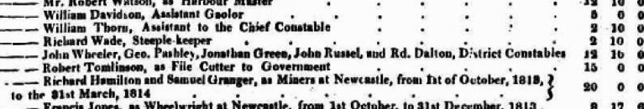  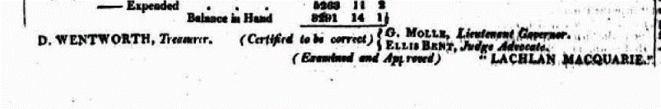
22nd July 1815  Age: 41 | Appointed Assistant Gaoler Sydney Gaol  Colonial Secretary’s Papers | 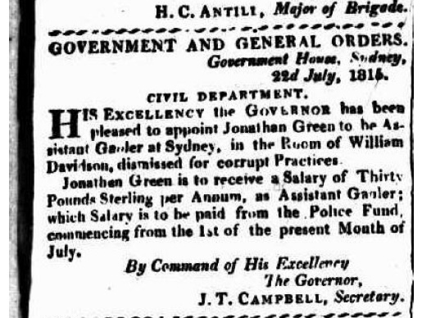  The Sydney Gazette and New South Wales Advertiser (NSW : 1803-1842), Saturday 22 July 1815, page 1  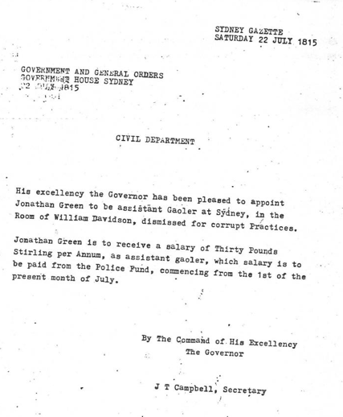
22nd July 1815  Age: 42 | Jonathan’s; family would have been eligible for rations under the conditions outlined here if they were present on Tuesday with Jonathan. It was harsh as you could not take time off to get your rations lest your family be struck off the Victualling List. A victualling list is a list of persons reliant on government wages a little bit like a muster. The document allowed the commissary to account for public expenditure on rations, clothing, utensils and other store items distributed to the people from temporary storehouses near the shores of Sydney Cove. https://www.bda-online.org.au/sources/victualling-lists/ | 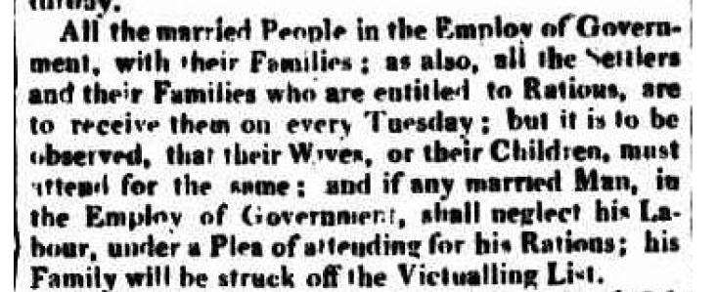  The Sydney Gazette and New South Wales Advertiser (NSW : 1803-1842), Saturday 22 July 1815
1st Jan 1816  Age: 43 | Colonial Secretary’s Papers. It is worth noting that Mr Redman at this time is Chief Constable-keep your eye out for him. The Gaoler was Mr Cubbitt. | The Sydney Gazette and New South Wales Advertiser (NSW : 1803-1842), Saturday 11 May 1816, page 2  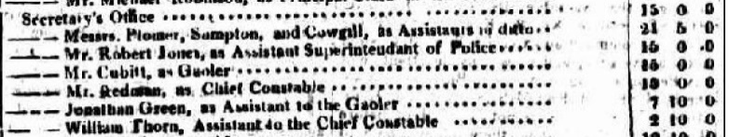  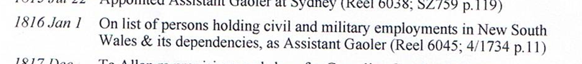
17th Feb 1816 | Jonathan is a benefactor for the Waterloo Charitable Fund. Note he is listed as Deputy Gaoler not an Assistant. | 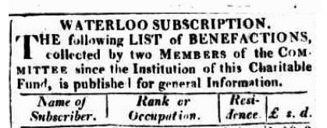  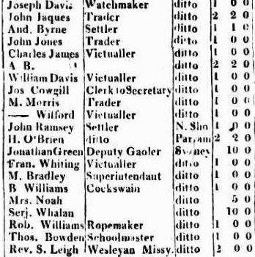  Sydney Gazette and New South Wales Advertiser (NSW : 1803 - 1842), Saturday 17 February 1816, page 1
3rd May 1817  Age 44 | Jonathan remains an assistant gaoler and the Treasurer Darcy Wentworth announces the salaries for the quarter ending March 31st. We know then that Jonathan received 7 pounds 10 a quarter the same as in 1816. Notice the gaoler has now changed to Mr John Jacques. | The Sydney Gazette and New South Wales Advertiser (NSW : 1803-1842), Saturday 3 May 1817, page 2, 3  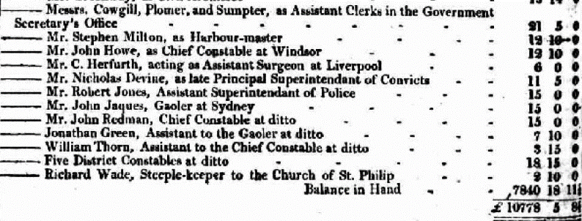  National Library
20th Dec 1817 | Jonathan is in charge of Cornelius Crawley.  The letter identifies that JT Campbell is asking to send forthwith on board The Harriet provisions for and evidence in the affair of the ship Chapman who is just about to embark. He asks that Cornelius be given a suit of hops and a shirt.  Cornelius looks to be a prisoner under Jonathan’s charge.  The only Cornelius Crawley in the Colonial Secretary’s papers arrives in 1825!  The last word in the letter ,looks like sailor so perhaps that was what Cornelius was. We know that the ship Chapman was a convict ship in 1817. The Chapman departed Cove of Cork, Ireland in company with the Pilot on 25 March 1817.  The affair on the Chapman looks like a mutiny on 17th April and a second one on 27th-28th April. Colonial Secretary John Thomas Campbell held a muster of 176 male prisoners on 31st July and 1st August 1817. It appears that convict Michael Collins made up a story of mutiny on 17th April which threw seaman and the ships executive into a panic.  At last, on April 18, a cook on sentry duty near the convicts shouted an alarm. Seamen and troops rushed to arms and fired indiscriminately through the bulkheads. Terry Kiernan, a convict, told the court of inquiry that most of the convicts were in bed, and all were in irons when the shooting began. He heard third mate Baxter shout, "Fire away, boys, and kill them all." The firing continued for an hour and a half, although the convicts had cried for quarter from the fourth shot. Even then the frightened crew would not enter the convict quarters. The wounded and dying convicts, floundering in the dark, bled and suffered until dawn when a strong armed party ventured in. The dead were thrown overboard, the wounded taken to hospital and the remainder double-ironed.  https://remembering-the-past-australia.blogspot.com/2017/06/the-hell-ship-the-chapman-1817.html  After the Chapman arrived and Governor Macquarie heard of the cruelty towards convicts, a colonial enquiry was undertaken.  Cornelius Crawley was in fact a seaman on the Chapman.  Macquarie sent a letter to Earl Bathurst stating  I have now the honour to inform your Lordship that Three Soldiers of the 46th regt., who belonged to the detachment on board the Chapman, namely James Clements, John Hogan, and John Jordan, are now embarked on the ship Harriet as prisoners for trial on specific charges of murder, and Mr. Alexander Dewar, Surgeon in R.N. and Lieut. Busteed of the 69th regt., who commanded the Military Guard on board are also embarked under close Military Arrest to abide such charges as may be prefered against them; with these, are also embarked as witnesses ten soldiers and fourteen convicts.  https://www.freesettlerorfelon.com/convict_ship_chapman_1817.htm  Maybe Crawley was imprisoned here as he is still here in 1818 but the use of the word subsistence may imply that he could have been a witness to the cruelty on the Chapman.  Wonder if Thomas Crawley was his brother? | 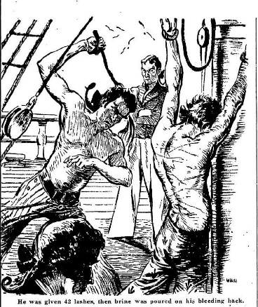  CHARGE OF MURDER ON BOARD A CONVICT SHIP  The Edinburgh Annual Register 1819  Admiralty Sessions, Tuesday, January 12, 1819.  CHARGE OF MURDER ON BOARD A CONVICT SHIP  The Edinburgh Annual Register 1819  Admiralty Sessions, Tuesday, January 12, 1819.
28th November 1818  Age 45 | Payment for the quarter ending 30th Sept 1818. Still on the same salary. John Jacques is now Keeper of Sydney Gaol and Jonathan remains his assistant. John Jacques had been listed as a trader in 1816. | 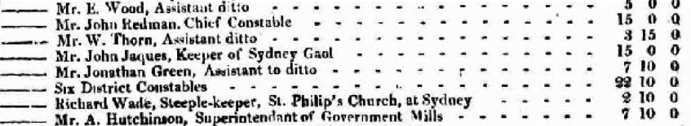
Feb 14th 1818 | Reimbursement for brooms supplied to Sydney Gaol. John Jacques in this edition is also listed as supplying sundry items of cooperage ie alcohol production and John Redman continues to be listed as he has been for many years as supplying the schooner Mary and firewood for the goal. They were agile businessman in those days. | 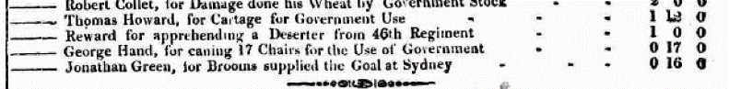  The Sydney Gazette and New South Wales Advertiser (NSW : 1803-1842), Saturday 14 February 1818, page
20th Feb 1819  Age 46 | Jonathan is still assistant gaoler. This role was a public servant role and would have carried some status one would think. | 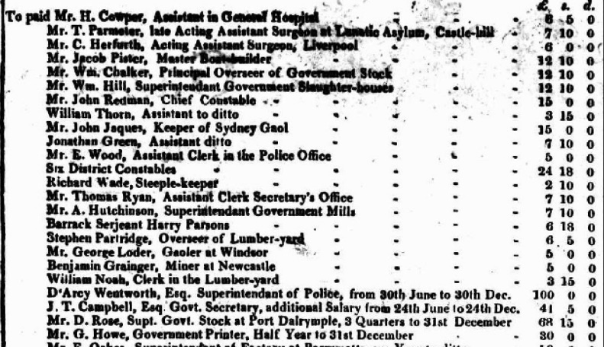  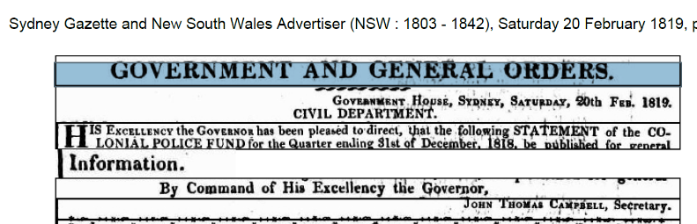
10th November 1819  New South Wales Land and Stock, 1819 | Shows Jonathan has 1 horned cattle and what looks like 8 hops which could relate to bushels of… | 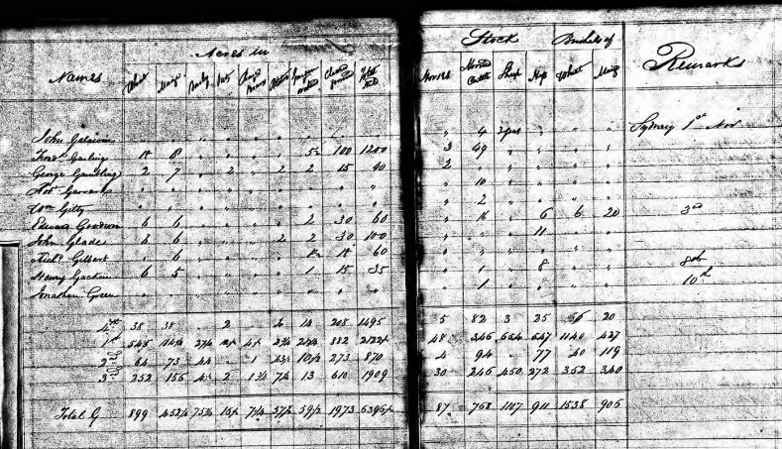
19th October 1820  Age 47 | Jonathan is sacked for drunkenness being incapable of looking after prisoners s described in Colonial Secretary papers. The fact john Redman was appointed in Jonathan’s wake indicates the level of seniority that the position actually held. Prior to this John Redman was the Chief Constable.  Ref: Change and challenge a history of the municipality of canterbury 2013 says:  Redman was indeed a good businessman and had given up trading by 1820, He then was appointed to Jonathan’s job and later to Gaol Keeper. Redman retired from government service in 1832 and died five years later at the advanced age of 75. He was a convict having arrived in 1790 for a 14 year sentence. He was pardoned and then appointed Chief Constable prior to 1807.  https://issuu.com/canterburylib/docs/change_and_challenge_a_history_of_t/39 | 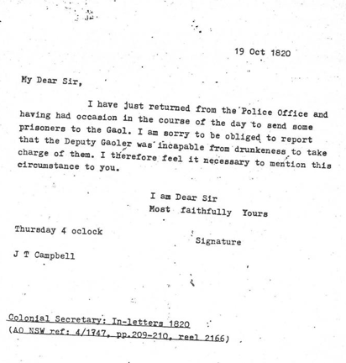  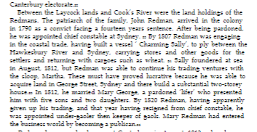  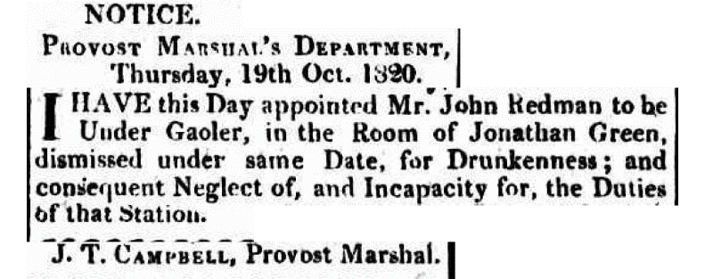
11th Nov 1820 | Jonathan is paid as assistant gaoler in arrears for 31st March to 30th June. | 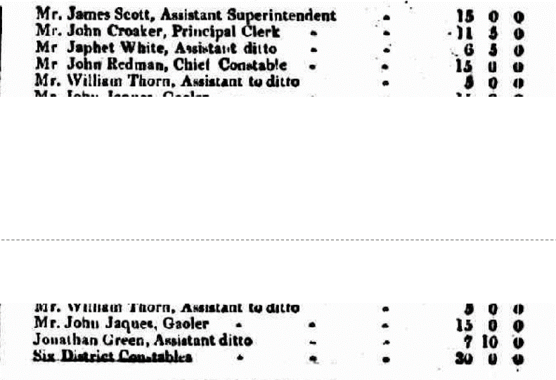  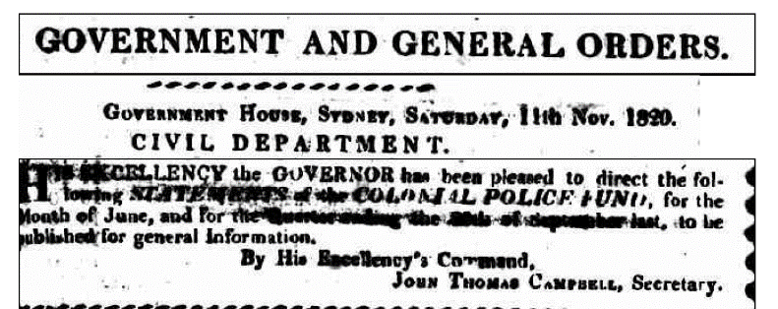
13th Nov 1820 | Jonathan and his family are taken off the government rations list.  There was a second twofold division of an economic rather than social nature crossing that of convicts and free, the division, namely, between those who received rations from the Government stores and those who did not—between the "victualled" and the "not-victualled". To those who were "on the store," a ration of meat and grain varying with the harvests and the frequency of home supplies, was served out each week, and in 1811 Government provided 4,227 full rations.^{[1]} As these included the half rations for women and quarter rations for children, https://en.wikisource.org/wiki/Page:A_colonial_autocracy,_New_South_Wales_under_Governor_Macquarie,_1810-1821.djvu/36  Jonathan would have to provide for his family now as he was non victualled.  Spencer Hall would have been 1 yrs old, John Thomas 3 yrs, Amelia Frances 6 yrs, Henry 12 yrs and George 16. Frances was married and had William Richard aged 2 by this stage and Jonathan Cooper would have been 20 yrs . Perhaps George was also working and independent at this stage. | 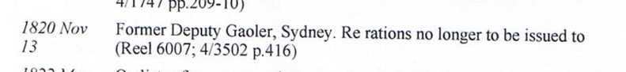
11th December 1820 | John Redman becomes Gaoler 2 months after being appointed into Jonathan’s assistant gaoler role and following the death of John Jacques. Notice Jonathan is still mentioned here and Richard Dalton takes his place.  Such a public dismissal for drunkenness must have been quiet shameful especially in such a job where you would create enemies. | 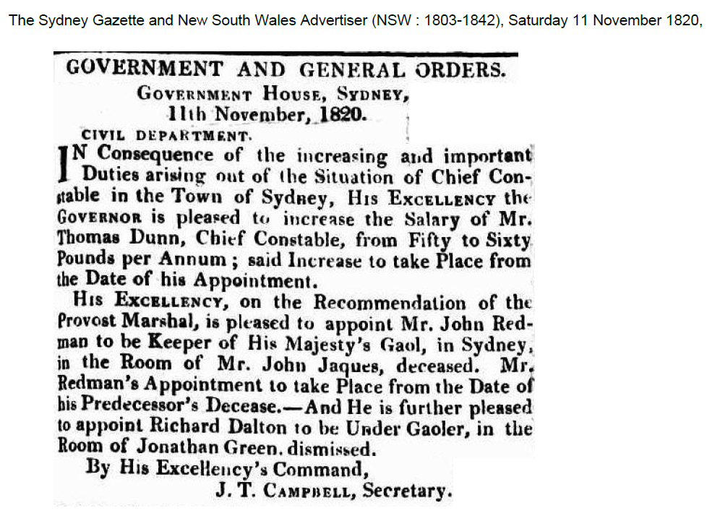
1821  Age 48 | Did Jonathan leave the colony? If so for what reason? On 22nd December 1821 the Brig Active was still in Sydney Harbour. Ref: Trove.  It would appear the Brig Active was heading to New Zealand.  It was purchased by Samuel Marsden in March 1814 for the purpose of using it as a trading and passenger vessel between Sydney, New South Wales, Australia, and the proposed mission settlement in New Zealand. https://www.wikitree.com/wiki/Space:Active_%28Brig%2C_Nov/Dec_1814%29  He owned it for 10 years so would have been the owner in 1821.  Maybe Jonathan was escaping public scrutiny or maybe working the ship as he no longer had employment. | 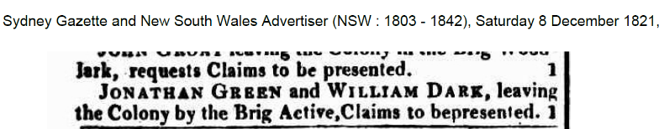  This may well be Jonathan Cooper Green also who would have been 21 years of age by now. He in fact died on 24th May 1823 at Windsor so if he did leave he returned within 2 years.  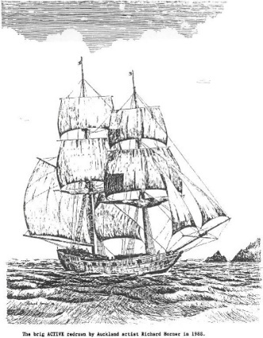  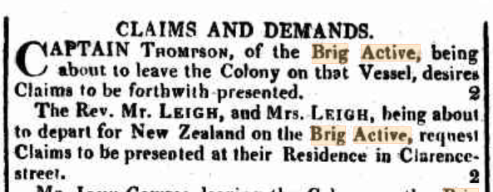  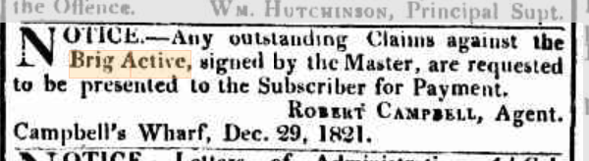  Sydney Gazette 1st Dec 1821
1822 Muster | In 1822 Jonathan is listed as Provost Marshall and Bailiff. That is a quick return to status! Or maybe not.  The Colonial Secretary Papers does say he was listed as a District Constable from 1820-1823 so maybe he returned to this role after being sacked as Deputy Gaoler. Note the term repeated drunkenness here!  Jonathan Cooper Green is listed as coming free as is Elizabeth and the children living with them are Henry downwards so George has found employ elsewhere. | 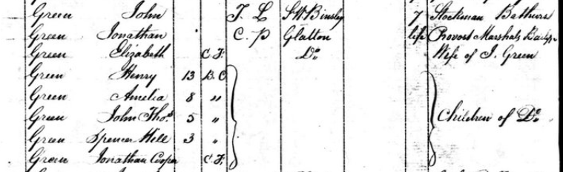  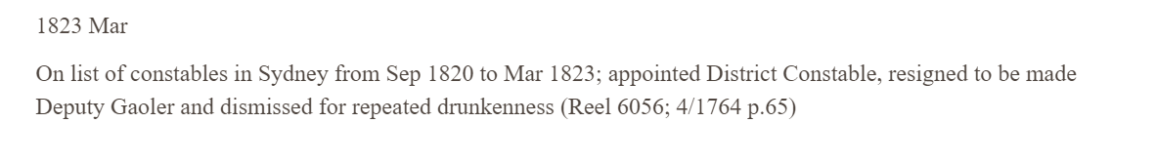
31 March-30 Sept 1822  Age: 49 | Jonathan’s standing must not be too bad if he is assigned convict mechanics. Jonathan has clearly entered into paying a convict mechanic. Perhaps he has returned or commenced his new profession as a nailor. | 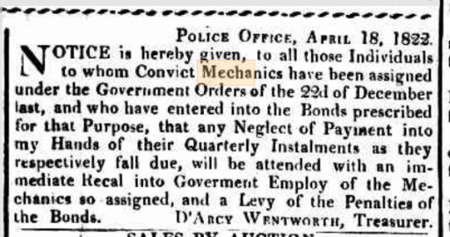  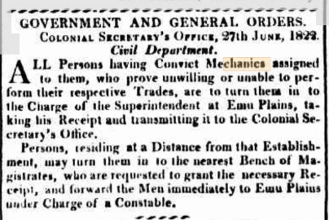  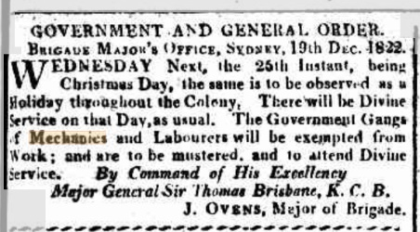
March 29th  1834  Age: 59 | Jonathan is clearly now a nailor of O’Connell St Sydney and is assigned a convict. A nailor is a metal worker producing nails by hand from a mould. Jonathan probably had the blacksmith shop in O’Connell St in 1834 as we know he had it in 1837. | 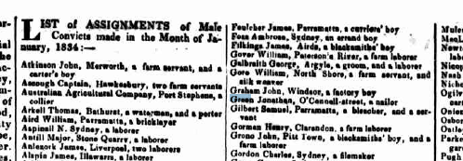  Sydney Gazette
Sept 26th 1836  Age: 62 | Jonathan gets into trouble again. We see a few differences here. He is a nailor residing in Pitt St not O’Connell St. He has a few men in his employ William Haynes a TOL man, a servant Charles O’Niel and John Laird who looks free. It appears Jonathan encouraged these three to violently assault a Gunsmith in Pitt St perhaps over a business issue? Jonathan got off lightly with a good behaviour type bond. The others not so. The degree of punishment here reflects their status. If you remained a convict like O’Niel you go the worst punishment.  Jonathan was branded an unfit person to be assigned any further servants.  The goal book from this time shows us what he looked like and that he was on bail so had sufficiency of funds.  Jonathan was 5 foot 6 inches tall, of stout figure at the age of 62 yrs with Grey hair and grey eyes. | 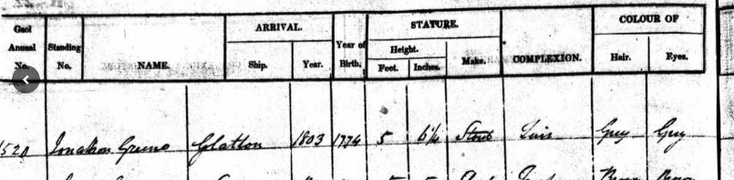  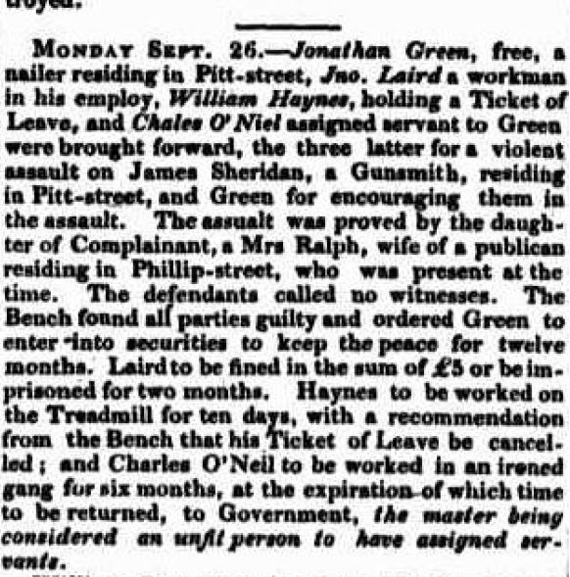
4th March 1837 | Jonathan is robbed at his blacksmith’s shop in O’Connell St where he is also described as residing. | Sydney Gazette  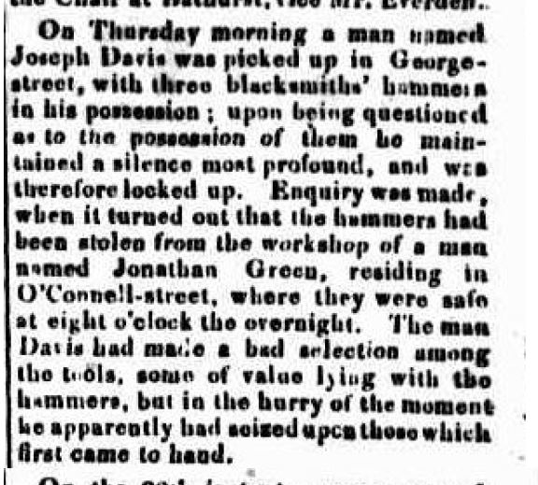
28th August 1844 | Jonathan died at O’Connell St Sydney aged 70 years. Not a bad innings in those days.

